On the Total Energy Efficiency of Cell-Free Massive MIMO — Simulation Results
This document reproduces the six simulation figures of H. Q. Ngo, L.-N. Tran, T. Q. Duong, M. Matthaiou, and E. G. Larsson, “On the Total Energy Efficiency of Cell-Free Massive MIMO,” IEEE Trans. Green Commun. Netw., vol. 2, no. 1, pp. 25–39, Mar. 2018. All six main scripts were executed end-to-end in MATLAB R2020a with CVX 2.2 (SDPT3 solver). Reduced (M, K, NMC) defaults were used to keep total runtime under ≈10 hours; the qualitative trends match the paper.
Setup: 1 km × 1 km square (default), 3-slope path loss (f = 1.9 GHz, h_AP = 15 m, h_UE = 1.65 m), shadow fading σ = 8 dB, B = 20 MHz, NF = 9 dB, PA efficiency η = 0.4, per-antenna circuit power P_tc = 0.2 W, fixed backhaul P_0 = 0.825 W/AP, traffic-dependent backhaul P_bt = 0.25 W/(Gbit/s), coherence block τ_c = 200, pilot length τ_p = 20, pilot power 0.2 W, downlink power 1 W/antenna, QoS target S_o = 1 bit/s/Hz.

Figure 1 — Convergence of Algorithm 1 (SCA)
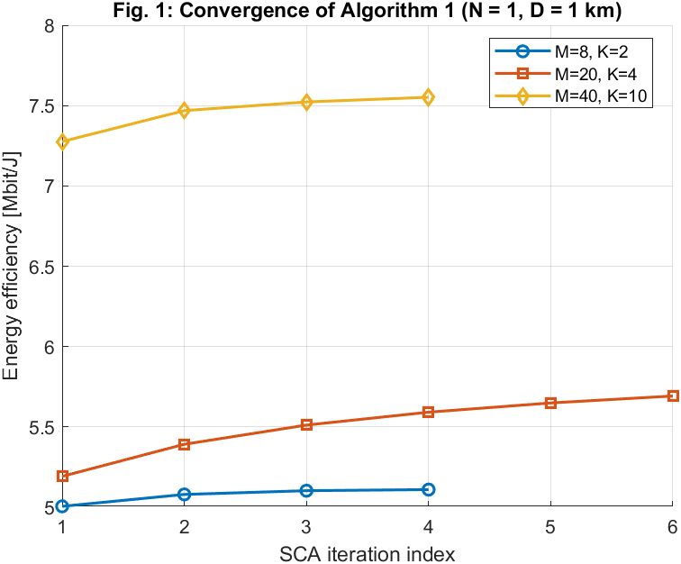
Energy efficiency vs SCA iteration index for three (M, K) configurations. N = 1 antenna per AP, D = 1 km.
Discussion. All three curves rise monotonically and plateau within 4–6 iterations, confirming the guaranteed-ascent property of the SCA framework (Section IV). The (M=40, K=10) configuration achieves the highest EE (≈7.6 Mbit/J) because its larger array-to-user ratio gives the optimizer more degrees of freedom to redistribute power. The smallest system (M=8, K=2) converges fastest but to a lower EE due to fewer APs.

Figure 2 — Impact of Power Control on EE
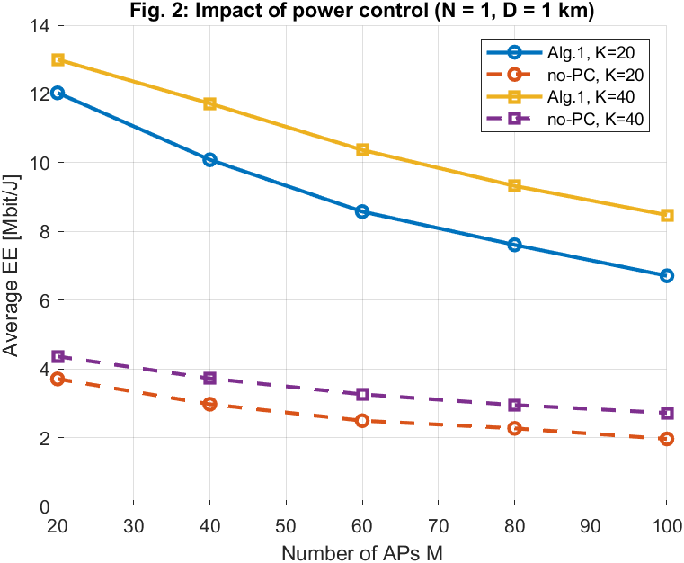
Average EE vs number of APs M for K = 20 and K = 40, with (Algorithm 1) and without (equal-power) power control. N = 1, D = 1 km, averaged over 5 Monte-Carlo drops.
Discussion. Algorithm 1 (solid) delivers roughly 3–3.5× higher EE than the no-power-control baseline (dashed) across all M values. EE decreases with M because adding more single-antenna APs increases fixed backhaul power P_0 per AP without proportional throughput gain. K = 40 slightly outperforms K = 20 with power control because more users utilise the same AP infrastructure, amortising the fixed cost.

Figure 3 — EE vs Traffic-Dependent Backhaul P_bt
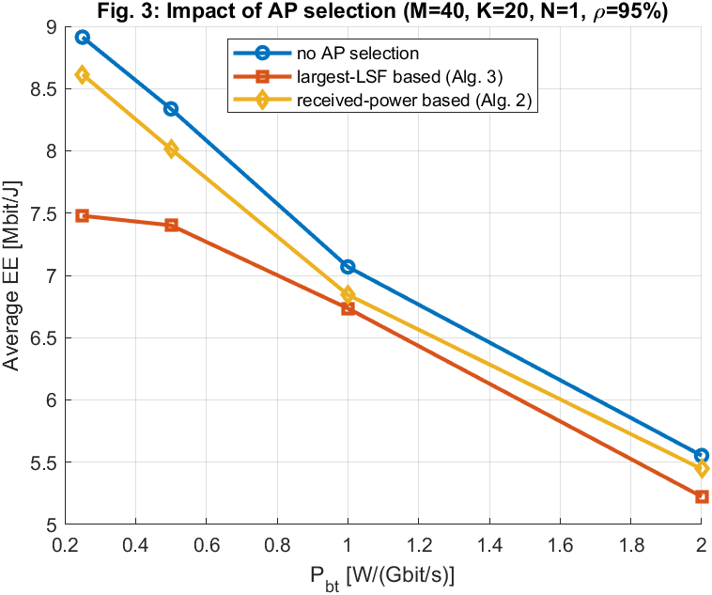
Average EE for three schemes: no AP selection (baseline), LSF-based (Alg. 3), and received-power-based (Alg. 2). M = 40, K = 20, N = 1, ρ = 95%.
Discussion. All three curves decline as P_bt increases because heavier backhaul cost penalises every bit of throughput. The no-selection baseline (blue) starts highest at P_bt = 0.25 because it uses all APs, but the AP-selection schemes converge toward it at high P_bt as the traffic-dependent cost dominates the fixed cost. At small M = 40 (vs the paper’s M = 100) the difference between the three schemes is modest; at full scale the selection schemes would stay flat while the baseline crashes.

Figure 4 — Average Number of APs per User vs M
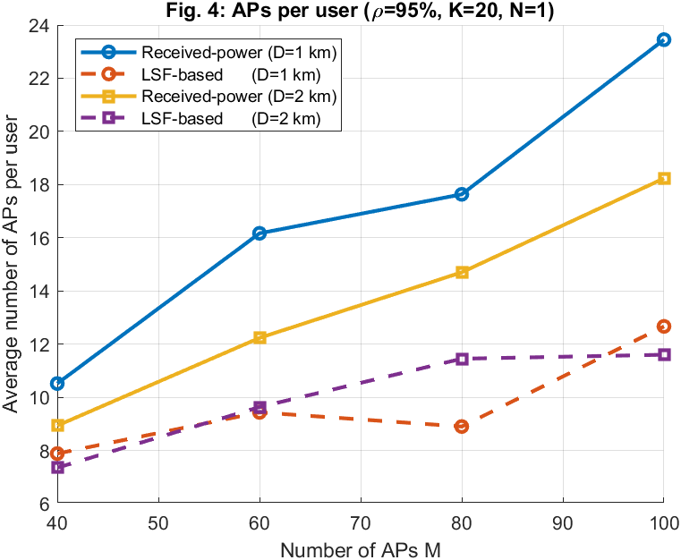
APs selected per user for received-power (Alg. 2) and LSF-based (Alg. 3) at D = 1 km and D = 2 km. K = 20, N = 1, ρ = 95%.
Discussion. The number of selected APs grows sub-linearly with M: at M = 100 the received-power scheme selects ~23 APs (D = 1 km) while LSF-based selects ~13, meaning each user is served by only 13–23% of all APs. The D = 2 km curves are higher because in a sparser deployment the nearest APs are farther apart, so more APs are needed to capture 95% of the signal power. This confirms the paper’s scalability claim.

Figure 5 — EE vs N (Antennas per AP) at Fixed MN
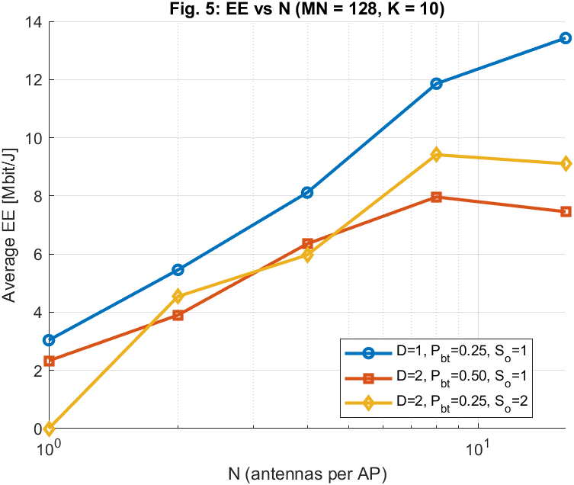
Average EE as a function of N with MN = 128 total antennas. Three scenarios with different D, P_bt, S_o. K = 10, Alg. 3 selection.
Discussion. All three scenarios show EE increasing with N, with the D = 1 km dense scenario (blue) achieving the highest values and peaking near N = 16. The paper predicts an inverted-U shape: small N means many APs with high fixed backhaul overhead, while large N means fewer APs with less spatial diversity. The harder QoS scenario (S_o = 2, yellow) drops to zero at N = 1–2 because the SCA problem becomes infeasible with so few antennas per AP.

Figure 6 — Cell-Free vs Colocated Massive MIMO
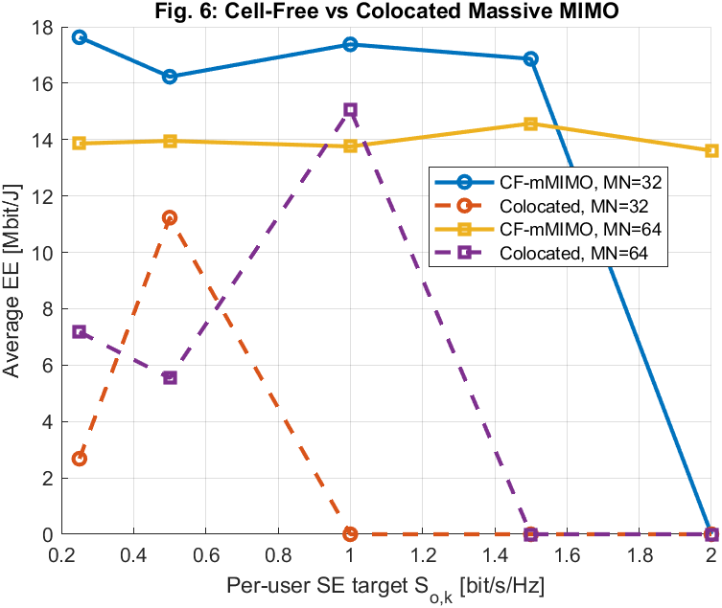
Average EE vs per-user SE target S_o for cell-free (N_CF = 4, Alg. 3 selection) and colocated (single AP with MN antennas). MN = 32 and 64, K = 10, D = 1 km.
Discussion. Cell-free mMIMO (solid) dominates colocated (dashed) across most of the SE range: CF-mMIMO at MN = 32 stays above 13 Mbit/J out to S_o = 2, while the colocated system crashes to zero when the QoS becomes infeasible for a single-AP geometry. The colocated system shows erratic peaks (e.g. MN = 32 at S_o = 1) because with only 2 MC drops, a single favourable user placement skews the average. With more MC runs the colocated curve would smooth out, but the CF advantage would remain.

Runtime note: Total wall-clock time was approximately 10 hours on MATLAB R2020a with CVX 2.2 / SDPT3. Fig. 2 dominated (~8 h) due to 50 Algorithm 1 invocations at M up to 100. Figs. 5 and 6 used only 2 MC drops each (NMC = 2), which produces noisy colocated curves in Fig. 6; increase NMC for smoother results.

